Embedded C Project

1. ABSTRACT: -

I have demonstrated 8 simple LED based projects using ATmega328 microcontroller, which will help you to learn its basic concepts. ATmega328 is an eight-bit AVR (Advanced Virtual RISC) based microcontroller. It is a powerful microcontroller with a built-in internal memory of around 32Kb. Most Arduino boards consist of an Atmel 8-bit AVR microcontroller with varying amounts of flash memory, pins, and features. Arduino Uno is a microcontroller board based on the ATmega328. AVR microcontrollers are very easy to use. All AVR microcontrollers require Integrated Development Environment (IDE) such as Atmel Studio. Using this IDE, we can create, compile and debug program on all AVR microcontrollers.

1. REQUIREMENT: -

2.1 Microcontroller

A microcontroller (MCU for microcontroller unit) is a small computer on a single metal-oxide-semiconductor (MOS) integrated circuit (IC) chip. A microcontroller contains one or more CPUs (processor cores) along with memory and programmable input/output peripherals. Program memory in the form of ferroelectric RAM, EEPROM, NOR flash or OTP ROM is also often included on chip, as well as a small amount of RAM. Microcontrollers are designed for embedded applications, in contrast to the microprocessors used in personal computers or other general-purpose applications consisting of various discrete chips. An AT Mega Microcontroller is an 8-bit microcontroller with Reduced Instruction Set (RISC) based Harvard Architecture. God to know: As the name suggest, for instance, “ATmega16″, where AT = Atmel, mega = mega AVR and 16= 16kb flash memory.

* 1. Led

A light-emitting diode (LED) is a semiconductor light source that emits light when current flows through it. Electrons in the semiconductor recombine with electron holes, releasing energy in the form of photons. The color of the light (corresponding to the energy of the photons) is determined by the energy required for electrons to cross the band gap of the semiconductor. White light is obtained by using multiple semiconductors or a layer of light-emitting phosphor on the semiconductor device.

* 1. Fixed Voltage

A fixed output power supply has, well, a fixed output voltage. This means that when the power supply is plugged in and the output is on, the output voltage is a single voltage that is not expected to change – it is fixed at that voltage. These power supplies are typically used to provide simple bias for a circuit.

* 1. Relay

A relay is an electrically operated switch. It consists of a set of input terminals for a single or multiple control signals, and a set of operating contact terminals. The switch may have any number of contacts in multiple contact forms, such as make contacts, break contacts, or combinations thereof. Relays are used where it is necessary to control a circuit by an independent low-power signal, or where several circuits must be controlled by one signal. Relays were first used in long-distance telegraph circuits as signal repeaters: they refresh the signal coming in from one circuit by transmitting it on another circuit. Relays were used extensively in telephone exchanges and early computers to perform logical operations

* 1. Buzzer

A buzzer or beeper is an audio signaling device, which may be mechanical, electromechanical, or piezoelectric (piezo for short). Typical uses of buzzers and beepers include alarm devices, timers, and confirmation of user input such as a mouse click or keystroke.

1. DESIGN: -

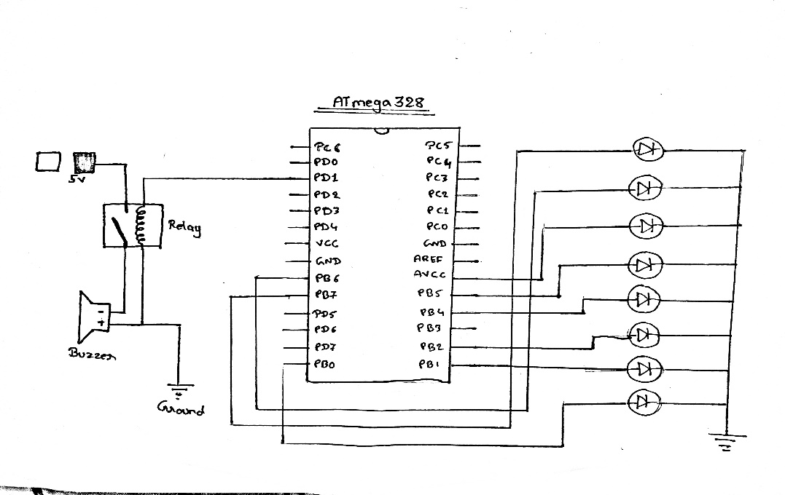

1. OUTPUT: -

